**Report No.3: Software Requirements Specifications (SRS)**

|  |
| --- |
| Project Success Criteria |
| * The project that finishes in scheduled time, within the allocated budgets and which satisfies the customer requirements. * All high-priority functionality defined in the requirements specification is delivered in the first release. * Open-sources are optimized closely, less complexity, improving quality of the system. * The estimated number of residual defects does not exceed 3 per function point. |

# 3.1. User Requirement Specification

|  |  |  |  |
| --- | --- | --- | --- |
| Type | Code | Name | Description |
| *Common User Requirement* | EL_CUR_UR1 | Interface | * The system shall provide Vietnamese interface. * The system need have the friendly graphical user interface, visual, lifelike, logical layout. |
|  | EL_CUR_UR2 | Announcement | The system will release an announcement if the result was not found. |
|  | EL_CUR_UR3 | Register/ login | Users can register and login easily and quickly. |
|  | EL_CUR_UR4 | Categorize | Data will be categorized efficiently to help user to search conveniently. |
|  | EL_CUR_UR5 | Question bank | The system will provide many kinds of exercises, questions and answers for students. |
|  | EL_CUR_UR6 | News providing | The system will provide news about education and university entrance exam… |
|  | EL_CUR_UR7 | Search | The system allows users to search for goods quickly, efficiently. |
|  | EL_CUR_UR8 | Testing online | Admin will create tests and user can choose a test to do. |
| *Business User Requirement* | EL_BUR_UR1 | Performance | The system should optimize to operate stably, improve quality to create competitive advantage. |
|  | EL_BUR_UR2 | Decentralization | The system need divide authority for each group: admin, mod, user, teacher… |
|  | EL_BUR_UR3 | Security | Commit that the system operate stably. It is very bad when users visit the website or manipulate on it while server die or other crash. |
|  | EL_BUR_UR4 | Statistic | The system will provide statistic about number of users visit the website. |
|  | EL_BUR_UR5 | Administrator | The system provide administrator site: admin can configuration for system and update database on the website. |
| *Single User Requirement* | EL_SUR_UR1 | Studying online | The system will provide theory site: showing theories and knowledge of subjects and refer exercises, and objectives. User can study and practice together. |
|  | EL_SUR_UR2 | Report | After testing, the system will send result for user. There are 2 kinds of report: basic and detail. The basic report will show point and time to use to user. The detail report will provide more information: detail about answers which user chooses. |
|  | EL_SUR_UR3 | Forum | The system will have forum site: this site is a place which members can share experience, discuss, and exchange some problems need care. |
|  | EL_SUR_UR4 | Case study | The system will provide case study for each question. Users can self-study better. |

# 3.2. System Requirement Specification (Specific Requirements)

## 3.2.1. External Interface Requirements

**3.2.1.1. User Interfaces**

A user behavior pane will be available in all workflow scenarios to allow easy access to online help and next-step options. The navigation options in every screen will be similar to lower or eliminate the system learning curve. Input confirmation and error notification will be consistent throughout the application.

**3.2.1.2. Hardware Interfaces**

- Common peripheral devices:

* ADSL (or wireless) modem and cable internet
* Mouse
* Keyboard

- Required (minimum) specifications:

* CPU: Intel® Pentium® 4 2.4 GHz or better supported
* RAM: 512MB (768MB for Windows 7)
* Hard Drive: 2GB of free space

- Recommended specifications:

* CPU: 2.4 GHz dual core or better supported
* RAM: 1GB for XP, 2GB for Windows 7
* Hard Drive: 2GB of free space

**3.2.1.3. Software Interfaces**

“E-Learning” system can run on any platform/operating system (includes Windows, Mac OS, and Linux). That support browsers listed below:

* Firefox (3.0 or higher)
* Google chrome (9.0 or higher)
* Internet Explorer (7.0 or higher)

**3.2.1.4. Communications Protocol**

The system will require communication via the Hyper Text Transfer Protocol (HTTP) to complete interactions based services with client computers. “E-Learning” system also requires a web browser to function. The Web Browser must comply with standards for HTTP version 1.0 or 1.1 HTTP version 1.0 is a well-founded and highly supported protocol. Now considering legacy by some organizations, we believe this is a safe foundation for the system.

The system also indirectly requires some network connection to the internet, over which it may communicate in HTTP. This network connection assumes a physical or wireless connection from the client computer to a consumer Internet Service Provider (ISP) or enterprise environment Local Area Network (LAN).

## 3.2.2. System Features

**3.2.2.1. Home**

The page is the “E-Learning” system home page, and will be showing whenever user load “E-Learning” website. This page looks like news site.

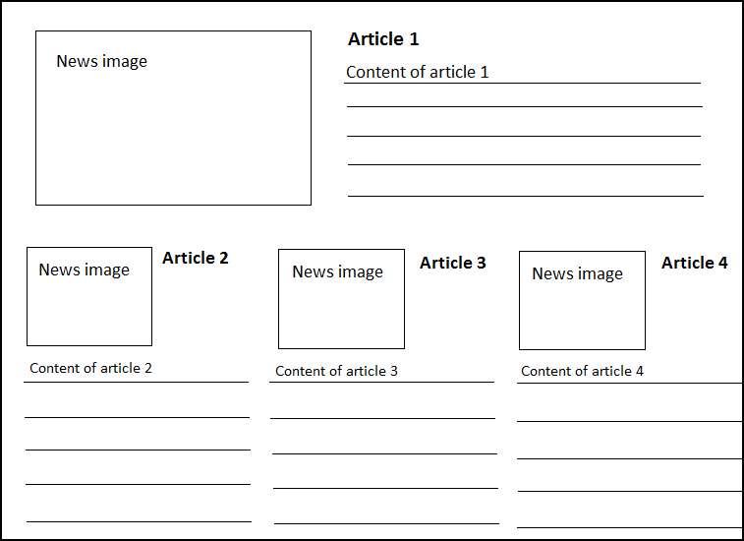

**Figure 3.1:** Home page

**3.2.2.1.1 Use Case Diagram**

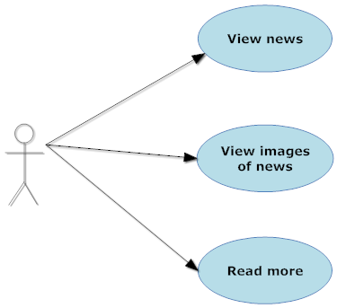

**Figure 3.2:** Home page use case diagram

**3.2.2.1.2 Use Case Specification**

**Use case 1**

|  |  |  |  |  |
| --- | --- | --- | --- | --- |
| **USE CASE- SPECIFICATION** | | | | |
| **Use-case No.** | UC001 | **Use-case Version** | | 1.0 |
| **Use-case Name** | View news | | | |
| **Author** | Huynt | | | |
| **Date** | 26/05/2012 | **Priority** | Normal | |
| **Actor:**  Visitor, Register Member, Admin  **Summary:**  After main page load, user can view news in the front page.  **Goal:**  Display news that user chose.  **Triggers**   * When user click on one of news link in the front page.   **Preconditions:**   * Main page loaded successfully * User select news in front page   **Post Conditions:**  Display news page  **Main Success Scenario:**  1. Main page is loaded with links news  2. User clicks on one of news link in the front page.  **Alternative Scenario:**  None  **Exceptions:**   1. Page is not loaded successfully. 2. News that selected is displayed wrongly.   **Relationships:**  This use case related to News page.  **Business Rules:**  - News must available for anyone visit website  - News must display in the front page of website  - News display content after user click on a link of its | | | | |

**Use case 2**

|  |  |  |  |  |
| --- | --- | --- | --- | --- |
| **USE CASE- SPECIFICATION** | | | | |
| **Use-case No.** | UC002 | **Use-case Version** | | 1.0 |
| **Use-case Name** | View images | | | |
| **Author** | Huynt | | | |
| **Date** | 26/05/2012 | **Priority** | Low | |
| **Actor:**  Visitor, Register Member, Admin  **Summary:**  After main page load, user can view images in the front page.  **Goal:**  Display images in the front page.  **Triggers**  None  **Preconditions:**   * Main page loaded successfully   **Post Conditions:**  Display images  **Main Success Scenario:**  1. Main page is loaded with collection of images.  **Alternative Scenario:**  None  **Exceptions:**  1. Page is not loaded successfully.  **Relationships:**  This use case related to Home page.  **Business Rules:**  - Images must available for anyone visit website  - Images must display in the front page of website | | | | |

**Use case 3**

|  |  |  |  |  |
| --- | --- | --- | --- | --- |
| **USE CASE- SPECIFICATION** | | | | |
| **Use-case No.** | UC003 | **Use-case Version** | | 1.0 |
| **Use-case Name** | Read more | | | |
| **Author** | Huynt | | | |
| **Date** | 26/05/2012 | **Priority** | Low | |
| **Actor:**  Visitor, Register Member, Admin  **Summary:**  After main page load, user can read more news “Tin tức” in the front page.  **Goal:**  Display full content of news that user chose to read more in front page  **Triggers**  When user click on “read more” link  **Preconditions:**   * Main page load successfully   **Post Conditions:**  Display content of a topic in news “Tin tức”.  **Main Success Scenario:**  1. Main page is loaded with an example of news.  **Alternative Scenario:**  None  **Exceptions:**  None  **Relationships:**  This use case related to Home page.  **Business Rules:**  - Content of News must available for anyone visit website  - Content of News must display in the front page of website | | | | |

**3.2.2.2. Theory libraries**

The features will allow user to choose theories about subjects to study. User need choose subject -> chapter -> theory. If a theory has learning’s video, the system will display the video below content of theory.

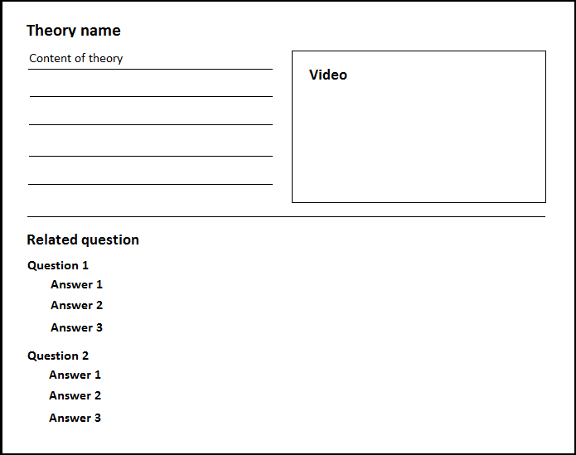

**Figure 3.3:** View content of theory page

**3.2.2.2.1 Use Case Diagram**

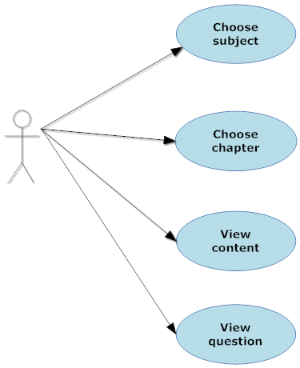

**Figure 3.4:** Theory libraries use case diagram

**3.2.2.2.2 Use Case Specification**

**Use case 4**

|  |  |  |  |  |
| --- | --- | --- | --- | --- |
| **USE CASE- SPECIFICATION** | | | | |
| **Use-case No.** | UC004 | **Use-case Version** | | 1.0 |
| **Use-case Name** | Chose subject | | | |
| **Author** | Huynt | | | |
| **Date** | 27/05/2012 | **Priority** | High | |
| **Actor:**  Visitor, Register Member, Admin  **Summary:**  After main page load, user can use theory library “Thư viện lý thuyết” component to chose subject to view.  **Goal:**  Display all chapter that subject (the one that user chose) contain  **Triggers**   * When user click on tab theory library”Thư viện lý thuyết” on the main menu or menu bar. * User click one of the list subject that display in front page or left menu   **Preconditions:**   * Theory Library page loaded successfully. * User select subject for display.   **Post Conditions:**  Show chapter of a subject in theory library page  **Main Success Scenario:**  1. User chose Theory Library page and the page loaded successfully  2. User clicks on a subjects in front page.  **Alternative Scenario:**  1. User chose Theory Library page and the page loaded successfully  2. User clicks on a subject in left menu.  **Exceptions:**   1. Page is not loaded successfully. 2. Chapter of subject display wrongly.   **Relationships:**  This use case related to Theory Library page and first step of view Theory process  **Business Rules:**  - Theory Library component must always available for anyone visits the website.  - System will display results which show the list chapters of subject they chose. | | | | |

**Use case 5**

|  |  |  |  |  |
| --- | --- | --- | --- | --- |
| **USE CASE- SPECIFICATION** | | | | |
| **Use-case No.** | UC005 | **Use-case Version** | | 1.0 |
| **Use-case Name** | Chose chapter | | | |
| **Author** | Huynt | | | |
| **Date** | 27/05/2012 | **Priority** | High | |
| **Actor:**  Visitor, Register Member, Admin  **Summary:**  After main page load, user can use theory library “Thư viện lý thuyết” component to choose chapter to view.  **Goal:**  Display all theory that chapter (the one that user chose) contain  **Triggers**   * User click one of the list chapter that display in front page   **Preconditions:**   * Theory Library page loaded successfully. * User select subject * User select chapter for display.   **Post Conditions:**  Show theory of a chapter in theory library page  **Main Success Scenario:**  1. User clicks on a chapter in front page.  **Alternative Scenario:**  1. User clicks on a chapter in front page. (chapters that are example of each subject)  **Exceptions:**   1. Page is not loaded successfully. 2. Theory of chapter display wrongly.   **Relationships:**  This use case related to Theory Library page and second step of view Theory process  **Business Rules:**  - Theory Library component must always available for anyone visits the website.  - System will display results which show list theories of chapter they chose. | | | | |

**Use case 6**

|  |  |  |  |  |
| --- | --- | --- | --- | --- |
| **USE CASE- SPECIFICATION** | | | | |
| **Use-case No.** | UC006 | **Use-case Version** | | 1.0 |
| **Use-case Name** | View content | | | |
| **Author** | Huynt | | | |
| **Date** | 27/05/2012 | **Priority** | High | |
| **Actor:**  Visitor, Register Member, Admin  **Summary:**  After main page load, user can use theory library “Thư viện lý thuyết” component to choose theory to view content.  **Goal:**  Display content and play video of theory that user chose to display  **Triggers**   * User click one of the list chapter that display in front page * User click play icon in video area   **Preconditions:**   * Theory Library page loaded successfully. * User select subject * User select chapter for display. * User select theory for display.   **Post Conditions:**  Show chapter of a subject in theory library page  **Main Success Scenario:**  1. User clicks on a theory in front page.  **Alternative Scenario:**  None  **Exceptions:**   1. Page is not loaded successfully. 2. Content or video of theory display wrongly.   **Relationships:**  This use case related to Theory Library page.  **Business Rules:**  - Theory Library component must always available for anyone visits the website.  - System will display results which show the content and video (if available) of theory they chose. | | | | |

**Use case 7**

|  |  |  |  |  |
| --- | --- | --- | --- | --- |
| **USE CASE- SPECIFICATION** | | | | |
| **Use-case No.** | UC006 | **Use-case Version** | | 1.0 |
| **Use-case Name** | View question | | | |
| **Author** | Huynt | | | |
| **Date** | 27/05/2012 | **Priority** | High | |
| **Actor:**  Visitor, Register Member, Admin  **Summary:**  After main page load, user can use theory library “Thư viện lý thuyết” component to choose chapter to view.  **Goal:**  Display, allow user answer and display the answer of question in theory that user chose to display.  **Triggers**   * User click one of the list chapter that display in front page * User click to link “Answer” bellow each question   **Preconditions:**   * Theory Library page loaded successfully. * User select subject * User select chapter for display. * User select theory for display.   **Post Conditions:**  Show chapter of a subject in theory library page  **Main Success Scenario:**  1. User clicks on a theory in front page.  **Alternative Scenario:**  None  **Exceptions:**   1. Page is not loaded successfully. 2. Question of theory display wrongly. 3. Answer of question display wrongly.   **Relationships:**  This use case related to Theory Library page.  **Business Rules:**  - Theory Library component must always available for anyone visits the website.  - System will display results which show the question of theory they chose and the answer. | | | | |

**3.2.2.3. Exercise libraries**

The features allow user to choose exercise to practice following subject, theory and difficult. User will choose subject -> chapter -> theory-> number of question -> difficult.

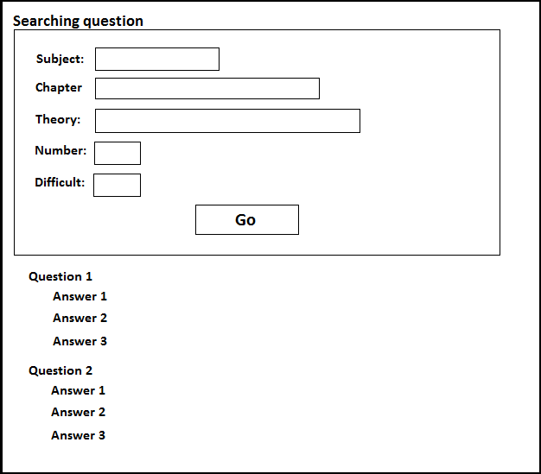

**Figure 3.5:** Exercise libraries page

**3.2.2.3.1 Use Case Diagram**

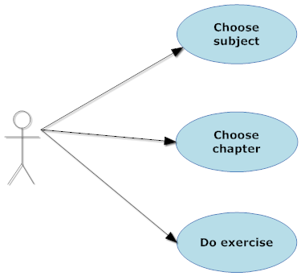

**Figure 3.6:** Exercise libraries use case diagram

**3.2.2.3.2 Use Case Specification**

**Use case 8**

|  |  |  |  |  |
| --- | --- | --- | --- | --- |
| **USE CASE- SPECIFICATION** | | | | |
| **Use-case No.** | UC008 | **Use-case Version** | | 1.0 |
| **Use-case Name** | Chose subject | | | |
| **Author** | Huynt | | | |
| **Date** | 27/05/2012 | **Priority** | High | |
| **Actor:**  Visitor, Register Member, Admin  **Summary:**  After main page load, user can use exercise library “Thư viện bài tập” component to chose subject to do questions.  **Goal:**  Display all chapter that subject contain (the one that user chose) in combo box  **Triggers**   * When user click on tab exercise library”Thư viện bài tập” on the menu bar. * User click one of the list subject that display in combo box in the front page   **Preconditions:**   * Exercise Library page loaded successfully. * User select subject for display.   **Post Conditions:**  Show list chapter of a subject in combo box of theory library page  **Main Success Scenario:**  1. User chose Exercise Library “Thư viện bài tập” page and the page loaded successfully  2. User clicks on a subject in combo box of front page.  **Alternative Scenario:**  None  **Exceptions:**   1. Page is not loaded successfully. 2. List chapter of subject display wrongly.   **Relationships:**  This use case related to Exercise Library page  **Business Rules:**  - Exercise Library component must always available for anyone visits the website.  - System display results which show the list chapters in combo box of subject they chose. | | | | |

**Use case 9**

|  |  |  |  |  |
| --- | --- | --- | --- | --- |
| **USE CASE- SPECIFICATION** | | | | |
| **Use-case No.** | UC009 | **Use-case Version** | | 1.0 |
| **Use-case Name** | Chose chapter | | | |
| **Author** | Huynt | | | |
| **Date** | 27/05/2012 | **Priority** | High | |
| **Actor:**  Visitor, Register Member, Admin  **Summary:**  After main page load, user can use exercise library “Thư viện bài tập” component to choose chapter to do questions.  **Goal:**  Display all theories that chapter contain (the one that user chose) in combo box  **Triggers**   * When user click on tab exercise library”Thư viện bài tập” on the menu bar. * User click one of the list subject and then chapter that display in combo box in the front page   **Preconditions:**   * Exercise Library page loaded successfully. * User select subject, chapter for display.   **Post Conditions:**  Show list theory of a subject in combo box of theory library page  **Main Success Scenario:**  1. User chose Exercise Library “Thư viện bài tập” page and the page loaded successfully  2. User clicks on a subject in combo box of front page.  3. User clicks on a chapter in combo box of front page.  **Alternative Scenario:**  None  **Exceptions:**   1. Page is not loaded successfully. 2. List chapter of subject display wrongly.   **Relationships:**  This use case related to Exercise Library page.  **Business Rules:**  - Exercise Library component must always available for anyone visits the website.  - System display results which show the list theory in combo box of subject they chose. | | | | |

**Use case 10**

|  |  |  |  |  |
| --- | --- | --- | --- | --- |
| **USE CASE- SPECIFICATION** | | | | |
| **Use-case No.** | UC010 | **Use-case Version** | | 1.0 |
| **Use-case Name** | Do exercise | | | |
| **Author** | Huynt | | | |
| **Date** | 27/05/2012 | **Priority** | High | |
| **Actor:**  Visitor, Register Member, Admin  **Summary:**  After main page load, user can use exercise library “Thư viện bài tập” component to do questions.  **Goal:**  Display all question in condition that user provide and answer (after user click on answer link)  **Triggers**   * When user click on tab exercise library”Thư viện bài tập” on the menu bar. * User click one of the list subject, chapter, theory, number of question and difficulty (optional) that display in the front page   **Preconditions:**   * Exercise Library page loaded successfully. * User select subject, chapter, theory, number of question and difficulty (optional) to do questions.   **Post Conditions:**  Display list of question in the previous condition that user have provide.  **Main Success Scenario:**  1. User chose Exercise Library “Thư viện bài tập” page and the page loaded successfully  2. User clicks on a subject in combo box of front page.  3. User clicks on a chapter in combo box of front page.  4. User clicks on a theory in combo box of front page.  5. User clicks on a number of questions in combo box of front page.  6. User clicks on a choice of difficulty in combo box of front page.(optional)  **Alternative Scenario:**  None  **Exceptions:**   1. Page is not loaded successfully. 2. List question display wrongly. 3. Questions answer display wrongly.   **Relationships:**  This use case related to Exercise Library page.  **Business Rules:**  - Exercise Library component must always available for anyone visits the website.  - System display results which show the list theory in combo box of subject they chose. | | | | |

**3.2.2.4. Register**

The page allow visitor to register as a member of “E-Learning” in order to use more of its features and receive member’s services.

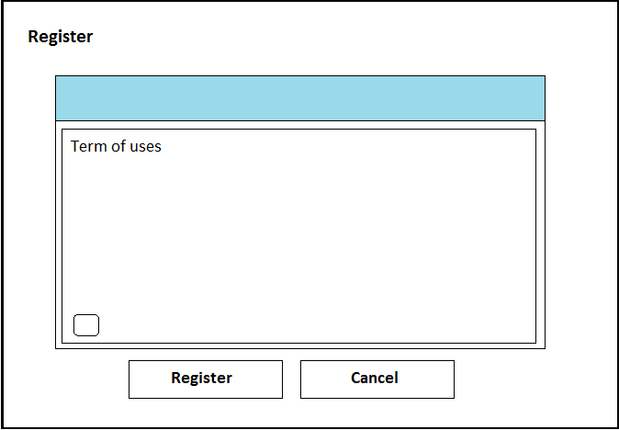

**Figure 3.7:** Register page

**3.2.2.4.1 Use Case Diagram**

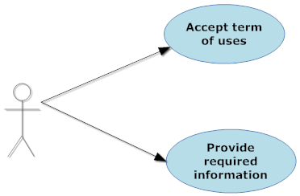

**Figure 3.8:** Register use case diagram

**3.2.2.4.2 Use Case Specification**

**Use case 11**

|  |  |  |  |  |
| --- | --- | --- | --- | --- |
| **USE CASE- SPECIFICATION** | | | | |
| **Use-case No.** | UC011 | **Use-case Version** | | 1.0 |
| **Use-case Name** | Accept term of use | | | |
| **Author** | Huynt | | | |
| **Date** | 28/05/2012 | **Priority** | High | |
| **Actor:**  Visitor  **Summary:**  Before registered as a member of “E-learning-website”, visitor must accept the website term of use, as well as they should read what they will receive once registered.  **Goal:**  Help visitor understand the term of use to avoid any unfortunate violation of website policies and to encourage to them willfully become a member of “E-learning website”  **Triggers**   * When user click on link “Create an account” in left menu of Home Page.   **Preconditions:**   * User doesn’t accept the term of use yet. * User chose to register.   **Post Conditions:**  Allow user to create an account.  **Main Success Scenario:**  1. User clicks on link “Create an account” in left menu of Home Page.  2. The term of use will show up.  3. User click on button “Tôi đồng ý với những điều khoản trên”  **Alternative Scenario:**   1. When user click on button “Tôi không đồng ý với những điều khoản trên” then go to forum page.   **Exceptions:**   1. Page is not loaded successfully. 2. List question display wrongly. 3. Questions answer display wrongly.   **Relationships:**  This case is the first step in register process.  **Business Rules:**  - Register function must always available for anyone visits the website.  - System display results which show the list theory in combo box of subject they chose. | | | | |

**Use case 12**

|  |  |  |  |  |
| --- | --- | --- | --- | --- |
| **USE CASE- SPECIFICATION** | | | | |
| **Use-case No.** | UC012 | **Use-case Version** | | 1.0 |
| **Use-case Name** | Provide required information | | | |
| **Author** | Huynt | | | |
| **Date** | 28/05/2012 | **Priority** | High | |
| **Actor:**  Visitor  **Summary:**  When register, user must provide their information, so that system can recognized them when they are login and also provide a way to communicate between user and website. **Goal:**  For system to recognize user when they are login  **Triggers**   * After user accept the Term of use   **Preconditions:**   * User chose to register. * User accepts the term of use.   **Post Conditions:**  Allow user to complete register after they fill in all mandatory field.  **Main Success Scenario:**  1. User accepts the Term of use.  2. Prompt user to fill in mandatory fields.  + User name “Tên thành viên”.  + Email. “Địa chỉ email”  + Verify Email “xác nhận địa chỉ email”.  + Password “Mật khẩu”.  + Verify password “Xác nhận mật khẩu”  . + Language “Ngôn ngữ”(optional).  + Time zone “Múi giờ”(optional).  + Confirmation code “Mã xác nhận”  3. After user fills all mandatory fields, allow user to complete register after click on accept “Chấp nhận” button.  **Alternative Scenario:**  None  **Exceptions:**   1. Page is not loaded successfully. 2. Page is not loaded successfully.   **Relationships:**  This case is the second step in register process.  **Business Rules:**  - In order to complete the registration, user must fill in all mandatory fields except time zone and language.  - The password should be at least 6 characters long and at most 100 characters. | | | | |

**3.2.2.5. Left menu**

This menu will be located on the left hand of website. It’s displayed on most of sites.

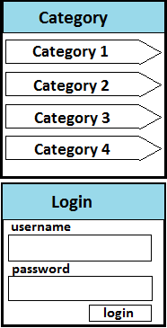

**Figure 3.9:** Left menu

**3.2.2.5.1 Use Case Diagram**

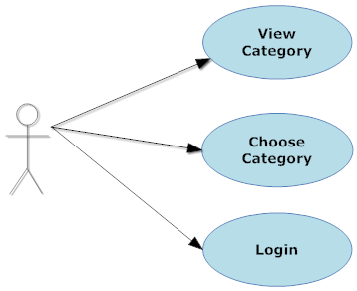

**Figure 3.10:** Left menu use case diagram

**3.2.2.5.2 Use Case Specification**

**Use case 13**

|  |  |  |  |  |
| --- | --- | --- | --- | --- |
| **USE CASE- SPECIFICATION** | | | | |
| **Use-case No.** | UC013 | **Use-case Version** | | 1.0 |
| **Use-case Name** | View category | | | |
| **Author** | Huynt | | | |
| **Date** | 29/05/2012 | **Priority** | Normal | |
| **Actor:**  Visitor, Register Member, Admin  **Summary:**  Each of categories is a link to a site of “E-Learning”. The categories can automatically cross out more of child categories. User can click on it to go to the site.  **Goal:**  Redirect to sites  **Triggers**   * When page is loaded. * User click on category hyperlink in left menu.   **Preconditions:**   * Page is loaded successfully.   **Post Conditions:**  The system will redirect the site to Home Page.  **Main Success Scenario:**   1. User click on category hyperlink in left menu.   **Alternative Scenario:**  None  **Exceptions:**   1. Page is not loaded successfully. 2. Cannot redirect to a site.   **Relationships:**  This user case is related to Home Page.  **Business Rules:**  - This link is always displayed. | | | | |

**Use case 14**

|  |  |  |  |  |
| --- | --- | --- | --- | --- |
| **USE CASE- SPECIFICATION** | | | | |
| **Use-case No.** | UC014 | **Use-case Version** | | 1.0 |
| **Use-case Name** | Choose category | | | |
| **Author** | Huynt | | | |
| **Date** | 29/05/2012 | **Priority** | Normal | |
| **Actor:**  Visitor, Register Member, Admin  **Summary:**  After user click on the category, the system will display the site according to the category.  **Goal:**  Display a site following category.  **Triggers**   * When page is loaded and user click on category hyperlink in left menu   **Preconditions:**   * Page is loaded successfully.   **Post Conditions:**  The system will redirect the site to category page.  List of subjects display in left menu  **Main Success Scenario:**   1. User click on category hyperlink in left menu.   **Alternative Scenario:**  None  **Exceptions:**  1. Page is not loaded successfully.  2. Cannot redirect to category page  **Relationships:**  This user case is related to category page.  **Business Rules:**  - This link is always displayed. | | | | |

**Use case 15**

|  |  |  |  |  |
| --- | --- | --- | --- | --- |
| **USE CASE- SPECIFICATION** | | | | |
| **Use-case No.** | UC015 | **Use-case Version** | | 1.0 |
| **Use-case Name** | Login | | | |
| **Author** | Huynt | | | |
| **Date** | 29/05/2012 | **Priority** | Normal | |
| **Actor:**  Register Member, Admin  **Summary:**  User has to input user name, and password to login to the system. If username or password is not valid, user cannot login to the system, and has to try again.  **Goal:**  Allow user login to the system.  **Triggers**   * When user click on “Login” hyperlink.   **Preconditions:**   * Page is loaded successfully. * User has valid user name and valid password to the system.   **Post Conditions:**   * In case of fail:   + User cannot login to the system.  + The system must give an error message.  + User has to try again to login.   * In case of success:   + The system gives a successful message.  + User login to the system successfully.  **Main Success Scenario:**  The use case start when:   1. Page is load successfully. 2. User click on “Login” hyperlink. 3. The system display a popup allow user to input user name and password. 4. User input username and password. 5. User press on “Login” button.   **Alternative Scenario:**  None  **Exceptions:**   1. Page is not loaded successfully. 2. The system does not load login panel.  * Connection too slow. * The system will allow user to reload page via “F5” button.  1. User input invalid user name  * The system will tell user about this error via message. * Return to step 4.  1. User input invalid password  * The system will tell user about this error via message. * Return to step 4   **Relationships:**  This user case is related to Login page.  **Business Rules:**  - After click on “Login” button, the system must display a message that allow user to input user name and password. In case of login fail, the system must display error message to inform user know the reason, invalid username, invalid password…  - User has to create account before login to the system. | | | | |

**3.2.2.6. Menu bar**

This menu includes links to main sites of the system. It is located under logo and banner.



**Figure 3.11:** Menu bar

**3.2.2.6.1 Use Case-n Diagram**

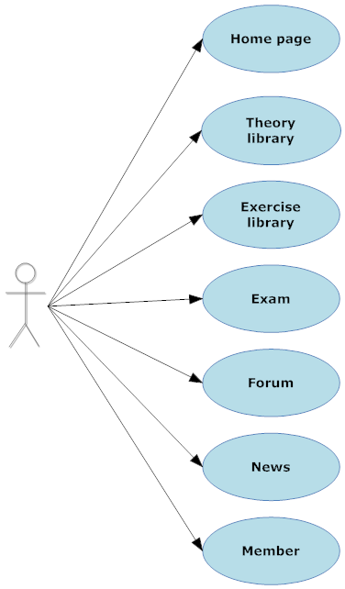

**Figure 3.12:** Menu bar use case diagram

**3.2.2.6.2 Use Case-n Specification**

**Use case 16**

|  |  |  |  |  |
| --- | --- | --- | --- | --- |
| **USE CASE- SPECIFICATION** | | | | |
| **Use-case No.** | UC016 | **Use-case Version** | | 1.0 |
| **Use-case Name** | Home page | | | |
| **Author** | Huynt | | | |
| **Date** | 29/05/2012 | **Priority** | Normal | |
| **Actor:**  Visitor, Register Member, Admin  **Summary:**  On each page, “Home” is a tab in menu bar. When user click on this tab, system will redirect the site to Home Page  **Goal:**  Redirect to Home Page  **Triggers**   * When page is loaded and user click on ‘Home” tab in menu bar   **Preconditions:**   * Page is loaded successfully.   **Post Conditions:**  The system will redirect the site to Home Page.  **Main Success Scenario:**   1. User click on ‘Home” tab in menu bar.   **Alternative Scenario:**  None  **Exceptions:**   1. Page is not loaded successfully. 2. Cannot redirect to Home Page   **Relationships:**  This user case is related to Home Page.  **Business Rules:**  - This tab is always displayed. | | | | |

**Use case 17**

|  |  |  |  |  |
| --- | --- | --- | --- | --- |
| **USE CASE- SPECIFICATION** | | | | |
| **Use-case No.** | UC017 | **Use-case Version** | | 1.0 |
| **Use-case Name** | Theory Library | | | |
| **Author** | Huynt | | | |
| **Date** | 29/05/2012 | **Priority** | Normal | |
| **Actor:**  Visitor, Register Member, Admin  **Summary:**  On each page, “Theory” is a tab. When user click on this tab, system will redirect the site to Theory Library Page  **Goal:**  Redirect to Theory Library Page  **Triggers**   * When page is loaded and user click on ‘Theory” tab in menu bar   **Preconditions:**   * Page is loaded successfully.   **Post Conditions:**  The system will redirect the site to Theory Library Page.  **Main Success Scenario:**   1. User click on ‘Theory” tab in menu bar.   **Alternative Scenario:**  None  **Exceptions:**  1. Page is not loaded successfully.  2. Cannot redirect to Theory Library Page  **Relationships:**  This user case is related to Theory Library Page.  **Business Rules:**  - This tab is always displayed. | | | | |

**Use case 18**

|  |  |  |  |  |
| --- | --- | --- | --- | --- |
| **USE CASE- SPECIFICATION** | | | | |
| **Use-case No.** | UC018 | **Use-case Version** | | 1.0 |
| **Use-case Name** | Exercise Library | | | |
| **Author** | Huynt | | | |
| **Date** | 29/05/2012 | **Priority** | Normal | |
| **Actor:**  Visitor, Register Member, Admin  **Summary:**  On each page, “Exercise” is a tab. When user click on this tab, system will redirect the site to Exercise Library Page  **Goal:**  Redirect to Exercise Library Page  **Triggers**   * When page is loaded and user click on ‘Exercise” tab in menu bar   **Preconditions:**   * Page is loaded successfully.   **Post Conditions:**  The system will redirect the site to Exercise Library Page.  **Main Success Scenario:**   1. User click on ‘Exercise” tab in menu bar.   **Alternative Scenario:**  None  **Exceptions:**  1. Page is not loaded successfully.  2. Cannot redirect to Exercise Library Page  **Relationships:**  This user case is related to Exercise Library Page.  **Business Rules:**  - This tab is always displayed. | | | | |

**Use case 19**

|  |  |  |  |  |
| --- | --- | --- | --- | --- |
| **USE CASE- SPECIFICATION** | | | | |
| **Use-case No.** | UC019 | **Use-case Version** | | 1.0 |
| **Use-case Name** | Exam | | | |
| **Author** | Huynt | | | |
| **Date** | 29/05/2012 | **Priority** | Normal | |
| **Actor:**  Visitor, Register Member, Admin  **Summary:**  On each page, “Exam” is a tab. When user click on this tab, system will redirect the site to Exam Page  **Goal:**  Redirect to Exam Page  **Triggers**   * When page is loaded and user click on ‘Exam” tab in menu bar   **Preconditions:**   * Page is loaded successfully.   **Post Conditions:**  The system will redirect the site to Exam Page.  **Main Success Scenario:**   1. User click on ‘Exam” tab in menu bar.   **Alternative Scenario:**  None  **Exceptions:**  1. Page is not loaded successfully.  2. Cannot redirect to Exam Page  **Relationships:**  This user case is related to Exam Page.  **Business Rules:**  - This tab is always displayed. | | | | |

**Use case 20**

|  |  |  |  |  |
| --- | --- | --- | --- | --- |
| **USE CASE- SPECIFICATION** | | | | |
| **Use-case No.** | UC020 | **Use-case Version** | | 1.0 |
| **Use-case Name** | Forum | | | |
| **Author** | Huynt | | | |
| **Date** | 29/05/2012 | **Priority** | Normal | |
| **Actor:**  Visitor, Register Member, Admin  **Summary:**  On each page, “Forum” is a tab. When user click on this tab, system will redirect the site to Theory Library Page  **Goal:**  Redirect to Forum Page  **Triggers**   * When page is loaded and user click on ‘Forum” tab in menu bar   **Preconditions:**   * Page is loaded successfully.   **Post Conditions:**  The system will redirect the site to Forum Page.  **Main Success Scenario:**   1. User click on ‘Forum” tab in menu bar.   **Alternative Scenario:**  None  **Exceptions:**  1. Page is not loaded successfully.  2. Cannot redirect to Forum Page  **Relationships:**  This user case is related to Forum Page.  **Business Rules:**  - This tab is always displayed. | | | | |

**Use case 21**

|  |  |  |  |  |
| --- | --- | --- | --- | --- |
| **USE CASE- SPECIFICATION** | | | | |
| **Use-case No.** | UC021 | **Use-case Version** | | 1.0 |
| **Use-case Name** | News | | | |
| **Author** | Huynt | | | |
| **Date** | 29/05/2012 | **Priority** | Normal | |
| **Actor:**  Visitor, Register Member, Admin  **Summary:**  On each page, “News” is a tab. When user click on this tab, system will redirect the site to News Page  **Goal:**  Redirect to News Page  **Triggers**   * When page is loaded and user click on ‘News” tab in menu bar   **Preconditions:**   * Page is loaded successfully.   **Post Conditions:**  The system will redirect the site to News Page.  **Main Success Scenario:**   1. User click on ‘News” tab in menu bar.   **Alternative Scenario:**  None  **Exceptions:**  1. Page is not loaded successfully.  2. Cannot redirect to News Page  **Relationships:**  This user case is related to News Page.  **Business Rules:**  - This tab is always displayed. | | | | |

**Use case 22**

|  |  |  |  |  |
| --- | --- | --- | --- | --- |
| **USE CASE- SPECIFICATION** | | | | |
| **Use-case No.** | UC022 | **Use-case Version** | | 1.0 |
| **Use-case Name** | Members | | | |
| **Author** | Huynt | | | |
| **Date** | 29/05/2012 | **Priority** | Normal | |
| **Actor:**  Visitor, Register Member, Admin  **Summary:**  On each page, “member” is a tab. When user click on this tab, system will redirect the site to Members Page  **Goal:**  Redirect to Members Page  **Triggers**   * When page is loaded and user click on “member” tab in menu bar   **Preconditions:**   * Page is loaded successfully.   **Post Conditions:**  The system will redirect the site to Members Page.  **Main Success Scenario:**   1. User click on ‘member” tab in menu bar.   **Alternative Scenario:**  None  **Exceptions:**  1. Page is not loaded successfully.  2. Cannot redirect to Members Page  **Relationships:**  This user case is related to Members Page.  **Business Rules:**  - This tab is always displayed. | | | | |

## 3.2.3. Software System Attributes

**3.2.3.1 Reliability**

**3.2.3.2 Availability**

**3.2.3.3 Security**

**3.2.3.4 Maintainability**

**3.2.3.5 Portability**

**3.2.3.6 Performance**

# 3.3. Entity Relationship Diagram or Data Structures

*<Provide the ERD Diagram for the system here. If your team uses a file or in-memory storage facility instead of a database, replace this section by ‘Data Structures’. Note, use only ERD or Data Structures>*